**Exp no11 - Creation and execution of Procedures.**

**use db;**

**show tables;**

**select * from product;**

**insert into product values(6,"geitost",3,12);**

**insert into product values(7,"konbu",4,40);**

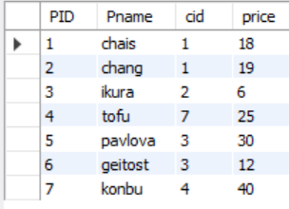

**DELIMITER //**

**create procedure sam(in pnr numeric(33))**

**begin**

**select * from product;**

**end //**

**create procedure sam1(in pnr numeric(33))**

**begin**

**select * from product;**

**end //**

**create procedure sam3(in pnr numeric(30))**

**begin**

**select * from product where price = pnr;**

**end //**

**DELIMITER //**

**create procedure sam4(out pnr numeric(3))**

**begin**

**select count(*) into pnr from product;**

**end //**

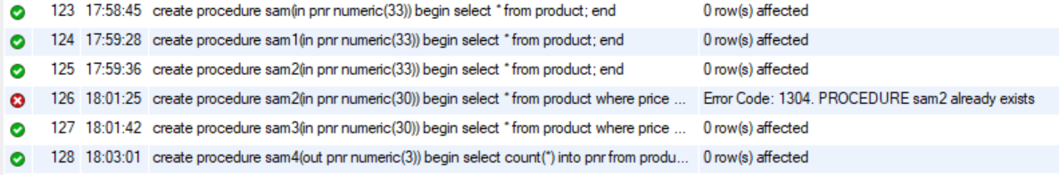

**Call sam(33);**



**Call sam3(33);**



**Call sam4(@a);**



**Select @a;**

